Strong inflation bypasses medicine prices
https://www.lif.dk/kraftig-inflation-gaar-uden-om-medicinpriserne/
Consumer prices have increased by 10 percent in the last year. This is the highest inflation in 40 years. But drug prices remain stable.
While the prices of bread, butter, energy, and most other necessities of life are rising sharply, buying medicine has largely not become more expensive.
This is shown by a review of the net price index from Statistics Denmark, which the Danish Pharmacists' Association and the Pharmaceutical Industry Association, Lif, have carried out.
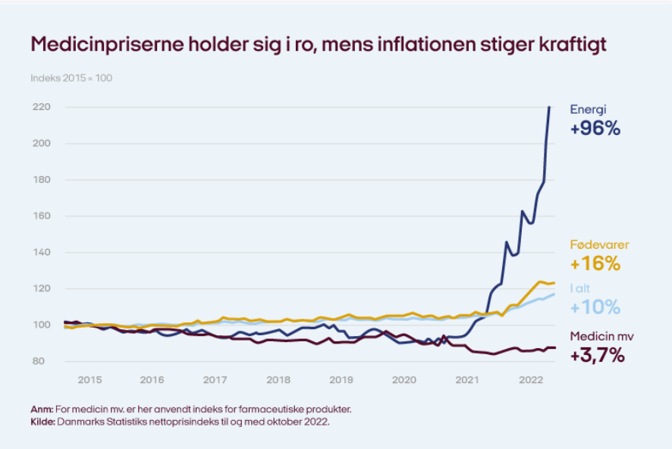
General consumer prices have risen by an average of 10 percent since the same period last year, the highest rate of inflation in 40 years. For example, food prices have increased by 16 per cent, and transport costs have risen by 11 per cent.
On the other hand, drug prices at the pharmacies are almost unchanged. In September 2022, they were on average only 3 percent higher than September last year – and there they were historically low.
"It is gratifying for the Danes that medicine prices are stable even at a time when we otherwise experience sharp price increases for ordinary goods. This not only benefits the individual drug user, but also reduces society's healthcare costs. It is clear that drug manufacturers also face increasing costs for energy, production and shipping, and therefore there is no guarantee that the trend of falling drug prices will continue unabated. But it is not the expectation that inflation will suddenly strike with full force in the medical field," says Ida Sofie Jensen, CEO of Lif.
Since 2007, public expenditure on drug subsidies has fallen by more than 10 percent, even though pharmacies today dispense 50 percent more subsidized drugs than in 2007.
So, more citizens are treated today with more and better medicine at a lower cost.

Facts about medicine prices
The prices of medicines are not set by the pharmacies, but by manufacturers and importers of medicines. They fight to be the cheapest in a kind of tender that the Danish Medicines Agency holds every fortnight. The pharmacies offer customers the cheapest package, and the medicine supplement is only given in relation to the lowest price.
New patent-protected medicines are subject to price ceilings so that the price cannot increase. At the same time, parallel importers can buy original medicines in another EU country at a lower price and sell them in Denmark. And when the patent expires, the manufacturers of copy medicine are ready to deliver.
This results in sharp competition among manufacturers and importers to be the cheapest, and in this way Denmark has one of Europe's freest and sharpest price competitions for medicines for the benefit of consumers.
Medicine prices have fallen almost constantly for the past 20 years, and they have been stable for the past year and a half. Overall, the prices of pharmacy medicines have halved since the year 2000.

