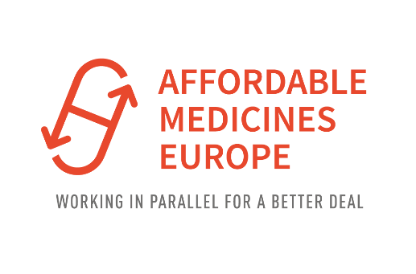

APPLICATION FORM FOR MEMBERSHIP

Your answers to the following questions will help the members of the Association to decide at a General Assembly, in keeping with the statutes, whether your application can be accepted. These questions are intended to check whether the applicant is a suitable candidate to become a member of the Association, according to the terms of the existing statutes and by-laws, and our Guidelines for Good Parallel Distribution Practice.

Please answer these questions as fully and as accurately as possible.
These questions apply to individual firms, as well as to each member firm belonging to a national association, if this association is applying for membership to Affordable Medicines Europe. In other words, it is compulsory for national associations to ask each of their member firms to fill in the application form and to forward the full set of completed forms to the Secretariat.

Name
(Please give both abbreviated and full forms)

Contact details
(Address, tel, e-mail and website)

Person to be contacted
(Name and e-mail)

Legal status (e.g. Ltd , Partnership, etc.)

VAT Number

Year of creation
Ownership
(present and future structure of shareholders)
GDP/GMP authorizations:
Please specify
- National wholesaler and/or manufacturer authorization number and date of issue and attach copy & English certified translation of the license
- Date of last inspection by the local authorities

Activities of the firm
(if there are several fields of activity, please state all fields, giving the corresponding % of the turnover during the last 12 Months)
To be filled in only by those applying as importers:
Turnover (during the last calendar year)
to be used as a basis to calculate the variable membership fee
Membership of other professional bodies in the pharmaceutical or regulatory areas (Please specify name and aims of these bodies, as well as your role and status in each of them
Name(s) of Affordable Medicines Europe member(s) who could provide a character reference

We will inform Affordable Medicines Europe, or the national association of which we are a member, immediately of any changes in company details and the status of the licenses mentioned above.
We hereby undertake to abide by the present statutes and by-laws of Affordable Medicines Europe, as well as the Affordable Medicines Europe’ Guidelines for Good Parallel Distribution Practice , as regards the pursuit of the parallel pharmaceutical trade within the EU/EEC and to refrain from all dealings and contacts liable to run counter to these objectives, or if necessary to refer to the Secretariat of the Affordable Medicines Europe in connection with any such matters.

Date: | Stamp and signature of applicant:

Please return the duly completed and signed Application Form to :
Kasper Ernest, Secretary-General Affordable Medicines EUrope
26 Rue des Deux Eglises, B-1000 Brussels
e-mail : ke@affordablemedicines.eu

