**MEDI–THEFT**

Data sharing and Investigative Platform

against Organised Thefts of Medicines

***Press Release***

|  |  |  |  |  |  |  |
| --- | --- | --- | --- | --- | --- | --- |
|  |  |  | |  | |  |
|  | |  | |  | | |

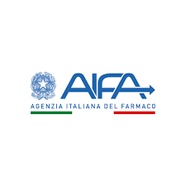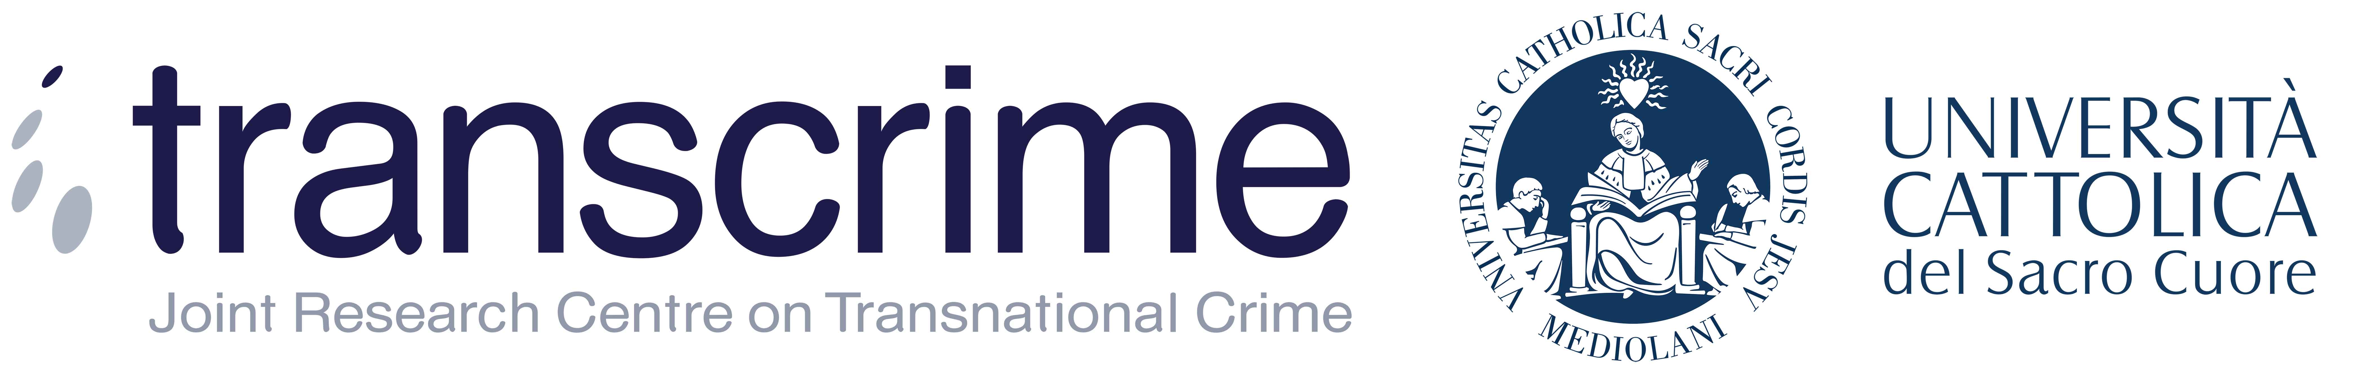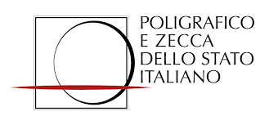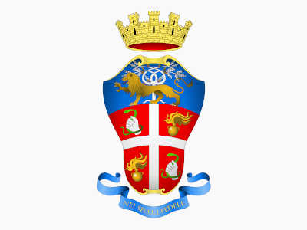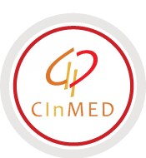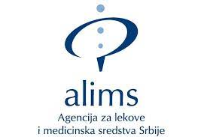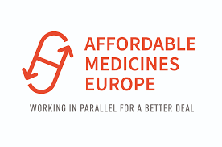

**EU-funded project MEDI-THEFT has been officially launched**

The EU funded project MEDI-THEFT – Data sharing and Investigative Platform against Organised Thefts of Medicines – has been launched starting from November 1st, 2021.

MEDI-THEFT aims to counteract medicine theft and reselling through the reporting, analysis and sharing of data to develop an intelligence-based platform.

Pharmaceutical thefts occur frequently, due to the high commercial value and to limited access to some medicines in some parts of the world.

In Italy but also in other EU Member States a high incidence of the problem has been recorded, as confirmed by the so-called “Operation Volcano” during which the investigations carried out have ascertained a consolidated and illicit trafficking of medicines stolen from Italian hospitals, as well as medicines that had been manipulated, falsified and re-introduced under false credentials (fake invoices) by unauthorized wholesalers.

In light of the trafficking identified during the Operation Volcano and of the serious health risks posed by the theft and the recycling of medicines, MEDI-THEFT’s main objectives are:

• Collect, share and analyze information related to medicine theft to identify and prevent criminals *modi operandi.*

• Produce and share early warnings to prevent stolen medicines to re-enter the legal market.

• Support and improve joint transnational investigations related to medicine theft.

During the MEDI-THEFT project the partners - Drug Regulatory Agencies and police forces of the EU Member States and pharmaceutical companies - will also collaborate to develop an ad hoc platform, with the support of the final users to implement a structured system for sharing and analysing data about the theft of medicines.

Currently, a centralized system to collect data about the theft of medicines does not exist in the EU Member States.

The project, ending October 2023, is funded by the Internal Security Fund Programme and led by AIFA with the participation of SAFE Foundation, Università Cattolica del Sacro Cuore - Transcrime, Istituto Poligrafico e Zecca dello Stato (IPZS), Affordable Medicines Europe (AME), Medicines and Medical Devices Agency of Serbia (ALIMS), Institute for Medicines and Medical Devices of Montenegro (CInMED) and Arma dei Carabinieri.

Further information will be provided through official online channels, such as AIFA and partners’ websites, LinkedIn and Twitter.